- Double click “sscom5.12” and maximize the window
- Select”English” and then click “EXT” button
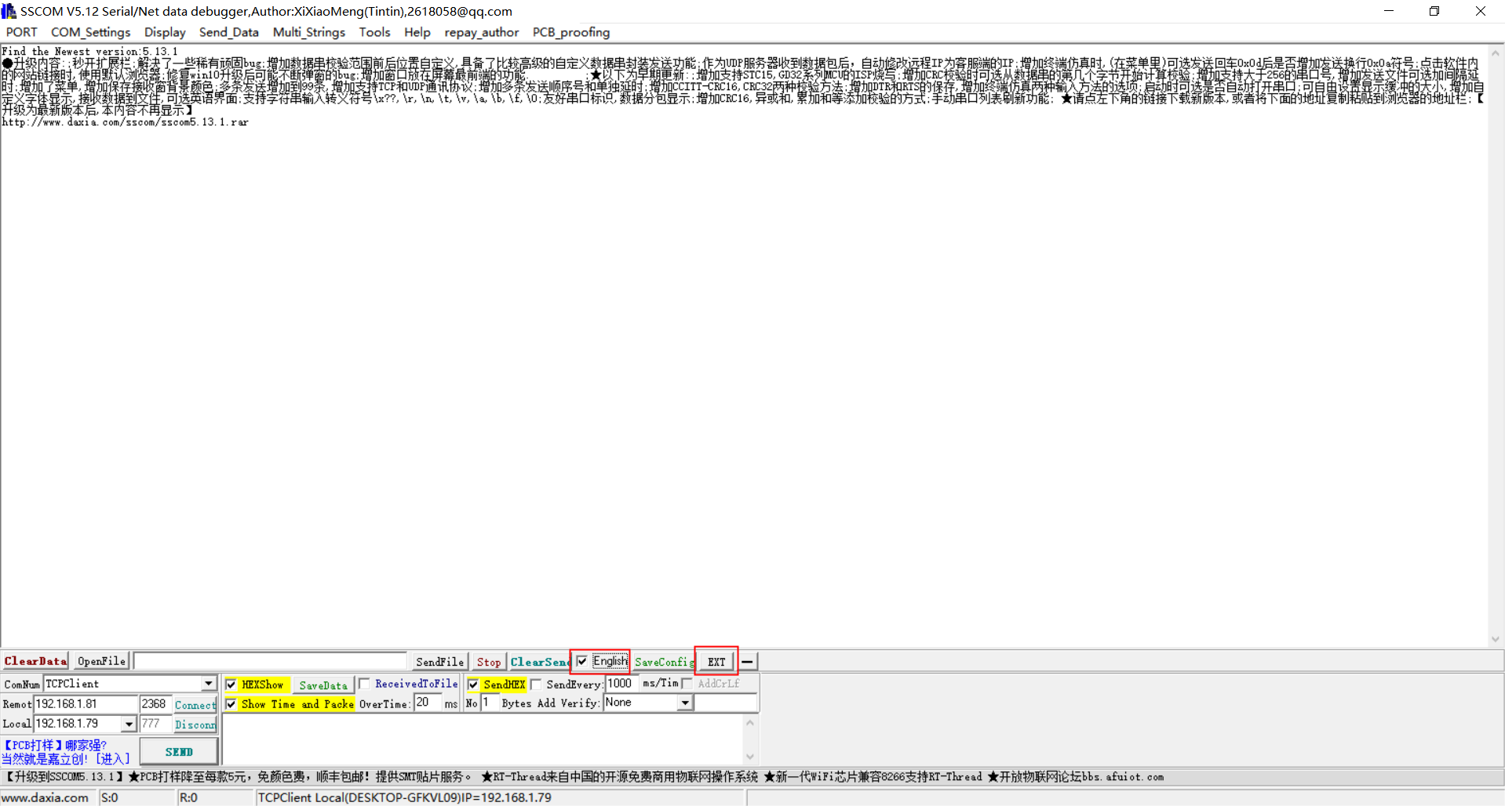
- Follow the procedure of following:
- Select correct COM port,if there is no correct COM,please download the driver of the USB-TTL adapter,if you can’t get the driver,please download and install the software “DriverGenius ”
- Select 115200 baud rate
- Click button “OpenCom”
- Set the output frame rate: it can be set to 250Hz, or it can keep the original 100Hz.
- Setting the address in IIC mode
- Do not click any address, the default configuration is “0x10”
- If multiple radars are connected to the same IIC bus, different addresses need to be configured.
- Click the corresponding address configuration command to complete the configuration.

- Click the "Change to IIC" button
